**REACT**

**#1**

**Created a new React Application with the name “myfirstreact”.**

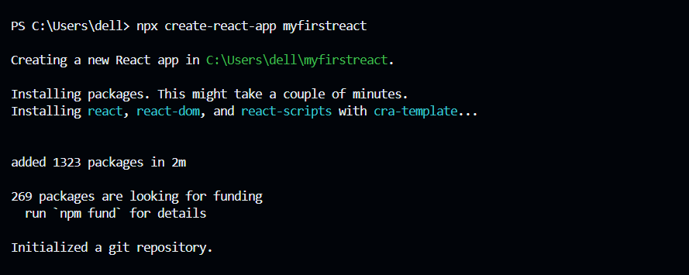

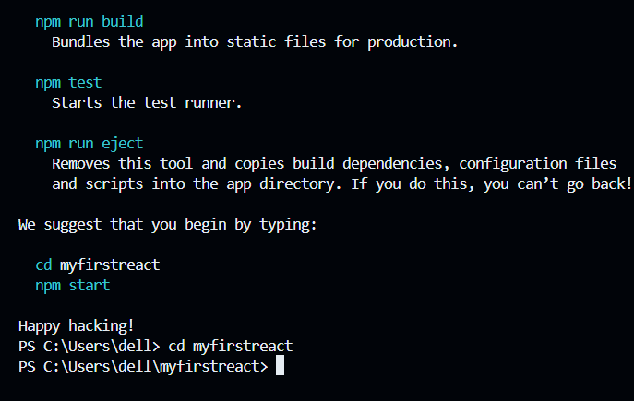

**Ran the application to print “welcome to the first session of React” as heading of that page.**

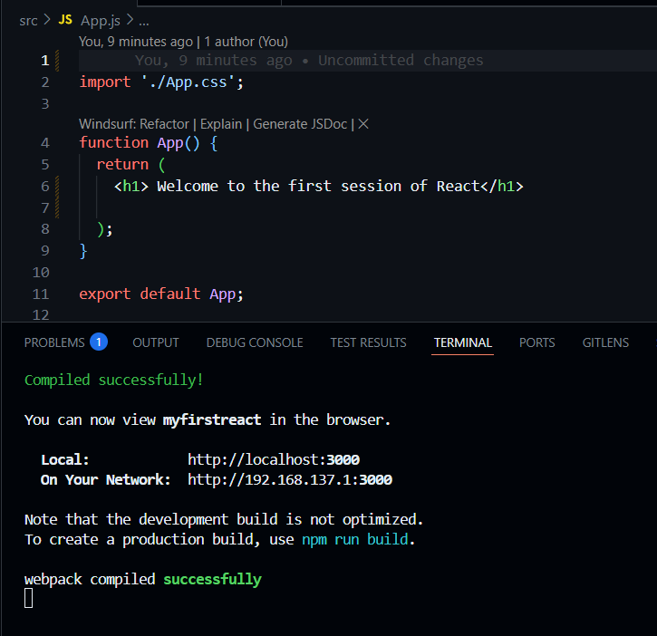

**OUTPUT -**

